Capstone Design

Midterm

**Team name:** Tesla

Tilavov Asilbek (001) 1810019

Khamraev Shukhrat (001) 1810025  
Kamilov Mirodil (001) 1810031

Musaev Abdulaziz (001) 1810072



**Our Agenda**

* What is Teamwork
  + Pros and Cons of Teamwork
* Introduction to our team
  + Our team name
  + Brief team member introduction
  + Our team’s main goal
* Duties and Responsibilities of Team Members
* The mission of the Team Members
* Team Operations Rules
* Making a Team Minutes
* Teaming Report
* Team Operations Schedules
* Assignment #1
* Midterm Project
* Summary

### 

### What is Teamwork

Teamwork is the collaborative effort of a group to achieve a common goal or to complete a task in the most effective and efficient way. This concept is seen within the greater framework of a team, which is a group of interdependent individuals who work together towards a common goal. A basic requirement for effective teamwork is adequate team size.

The four key characteristics of a team include

* a shared goal
* interdependence
* boundedness and stability
* the ability to manage their own work and internal process, and operate in a bigger social system

According to Andrew Carnegie, teamwork is the ability to work together toward a common vision. The ability to direct individual accomplishment toward organizational objectives. It is the fuel that allows common people to attain uncommon results.

Teamwork is important because it enables your team to share ideas and responsibilities, which helps reduce stress on everyone, allowing them to be meticulous and thorough when completing tasks. This will enable them to meet sales goals quickly.

**Pros and Cons of Teamwork**

**The advantages**

* Shared responsibility
  + Overseeing a major project at work can be a daunting task. You’ll need to ensure everything goes to plan, that you’re covering all bases, and that you achieve the right results. Sharing responsibility with a team can relieve some of the stress and ensure there are more eyes on the ball.
* Effective problem solving
  + When working alone, you are limited to your own sets of skills and experience. Working within a team is a great way to inject more ideas and ways of thinking into a project.
* Build stronger professional relationships
  + Successful companies are built on great teams, not just great individuals. Learning to work within a team is therefore essential to the greater good of the company.
* Teamwork is a platform for quality leadership
  + In order for a team to be productive, it must be led by a quality leader. One of the great things about teamwork is that it’s an opportunity for individuals to rise to the challenge of taking on more responsibility to organize and motivate the team.

**The Disadvantages**

* Not everyone pulling in same direction
  + One of the major drawbacks of teamwork is that sometimes, not everyone will pull in the same direction. Colleagues will have different opinions on how to do things or will seek to achieve different outcomes altogether. This will ultimately slow a project down and potentially derail it if there’s enough to-ing and fro-ing.
* Never-ending meetings
  + Anyone who has worked within a large team knows that meetings can eat up a large chunk of the working week. When you’re in a team, everyone needs to come to an agreement on the way forward. Any changes will not only need approval but will also need to be communicated effectively among the team.
* Potential for conflict
  + Naturally, within any team, there are likely to be very different people, with different perspectives and different ways of doing things. This can be a strength; however, it can also give rise to conflict when disagreements break out on which ideas to focus on or how to resolve problems. When not addressed and resolved, conflicts can cause serious setbacks.
* Team members seeking personal glory
  + On the flipside of this point, some individuals may be out to seek personal glory at the expense of everyone else in the team. This may lead to an individual trying to stand out by ignoring team efforts altogether to do their own thing.

### Introduction to our team

**Our team name**

We devoted our first meeting to brainstorm the goal and name of the team. After this meeting we all agreed to the name Tesla. We had an ambition to implement very basic and similar functionality of the Tesla cars. It was a role model and dream for us. I guess it also sounds easy to remember, creative, and professional.

**Brief team member introduction**

Our team has 4 members. Each team member has his own set of knowledge and skills. We formed a well rounded team as a whole diminishing each other's limitations. For example, the team leader - *Mirodil Kamilov* has good organizational skills. He can encourage people to work towards the goal as a united team. However, *Musaev Abdulaziz* has a solid mathematical background. He is also a good problem solver which automatically makes him a good algorithm designer. *Shukhrat Khamraev* has some experience in working with various hardware devices. As this course involves multiple hardware components which we had to interact with a lot, it is crucial that we had a hardware specialist in the team. Lastly, *Tilalov Asilbek* is good at testing software applications. He is currently working as an A/B tester in the industry. *All of our team members* have enough knowledge of programming to complete the assignments and projects.

**Our team’s main goal**

Our team’s main goal is gaining knowledge and experience about both different hardware components and the software that makes them work together. In short, getting thorough knowledge about different components of the smart kit and putting them to operate any dynamic map. Putting our theoretical knowledge into action by building some level of autonomous vehicle. In addition, we want to learn many different soft skills along the way, like working in a team, solving various problems, learning how to learn (because the course requires a lot of research) and others. Apart from that, our team set the bar high and aimed to be among the top students of the course.

### Duties and Responsibilities of Team Members

| **Role** | **Main Responsibility** |
| --- | --- |
| **Team leader** | As a team manager, manage the overall progress of the project and coordinate team members' views. |
| As a spokesperson for the team, convene and preside over the meeting, or report the results of the meeting to the supervisor. |
| **Recorder** | Record team members' suggestions and ideas, team decisions, and discussions. |
| Summarize or record team member mission reports and provide summarized documentation to all team members with the topic of the next meeting. |
| **Data collector** | Collect and organize online and offline materials related to team activities and provide them to team members. |
| **Surveyor** | Organize opinions of team members and make various reports and presentations. |
| **Report creator** | Responsible for team activity and presentation of results. |
| **Presenter** | Responsible for team activity and presentation of results. |
| **Facilitator** | Maintain team members' focus on the agenda and encourage participation. |
| The facilitator's role is especially important when there are four or more team members. |
| **Course observer** | Provide appropriate feedback on the progress of the team meeting. |
| Observe and feedback how well the task assignment and team meetings progress. |
| It acts like an internal audit by suggesting improvements. |

### The mission of the Team Members

According to the above-mentioned skills and knowledge of each member in the team, we agreed to assign the roles accordingly:

| **Team Name: Tesla** | | **Date: 06.02.2022** |
| --- | --- | --- |
| **Role** | **Name** | **Main Responsibility** |
| **Team leader** | Kamilov Mirodil | As a team leader, I am responsible for the overall progress of our team and make sure every team member is working towards the main goal of the team. As a part of my responsibility, I organize and manage team meetings to complete tasks. Delivering the software program is also my duty. |
|
| **Hardware specialist** | Khamraev Shukhrat | I am responsible for making sure every component (IR sensor, Line tracer, Ultrasonic, DC motors, camera, batteries, and others) of the smart kit is working properly. If not fixing it. |
|
| **Algorithm specialist** | Musaev Abdulaziz | I am responsible for developing highly efficient algorithms for every assignment and project. I am also responsible for coming up with solutions for the problems that our team struggles with. |
|
|
| **Tester** | Tilavov Asilbek | I am responsible for delivering the error-free software that works properly according to requirements of the task. Also, I would help with debugging the program to solve various issues. |

**Team Operations Rules**

Here are our team operational rules that we all agreed to follow during the semester. It involves our main rules (apart from code of ethics) and It may be subject to change in the future.

| **Team Operating Rules** | | | | |
| --- | --- | --- | --- | --- |
| **Team Name** | | Tesla | **Date** | February 06, 2022 |
| **Team Leader** | | Kamilov Mirodil | **Recorder** | Khamraev Shukhrat |
| 1. Regular meetings are held every Tuesday from 11:00 am to 12:00 am, and from 2:00 pm to 3:00 pm on Friday.  2. The starting time of the meetings will be strict. If someone in the team comes late more for more than 10 minutes, he/she will have to present free food for every other team member.  3. If someone in team members does not attend the meeting more than twice without any special reason, that person will be expelled from the team.  4. The role of the team members is subject to change every three weeks.  5. Any hurtful act or words to a team member can lead to expelling that person from the team unless he/she is really sorry for his/her act and persuaded not to repeat it again.  6. Decisions on important matters must be approved by at least three members at a team meeting attended by all the team members.  7. Other matters not specified in the Rules of Team Operations are determined through team meetings.  8. Three or more team members must agree to hold a meeting for the change of team operating rules.  9. All the assignment and project materials including the report, source code, additional materials must not be shared with anyone ***at*** ***any cost*** except the team members.  10. Team operation rules can be amended with the consent of the members. | | | | |
| **Team Members** | Kamilov Mirodil | Musaev Abdulaziz | Tilavov Asilbek | Khamraev Shukhrat |

### Making a Team Minutes

| **Team Minutes** | | | | |
| --- | --- | --- | --- | --- |
| **Team Name** | Tesla | | | |
| **Purpose** | Resolving the issues caused by the hardware components and their inconsistent results and increasing the efficiency of accuracy in moving | | | |
| **Date** | 25th February 2022 | | **Place** | B Building, INHA University in Tashkent |
| **Members** | **Leader** | Kamilov Mirodil | **Recorder** | Khamraev Shukhrat |
| **Participants** | Kamilov Mirodil, Musaev Abdulaziz,  Khamraev Shuhrat, Tilavov Asilbek | | |
| **Absentee** | None | | |
| **Decision of the last meeting** | DC motors, Ultrasonic sensors and IR sensors were put in action to avoid simple obstacles. It was completed in a simple scenario. | | | |
| **Meeting topics** | How to deal with the errors raised due to hardware components and to obtain a high level of accuracy of movement | | | |
| **Conference decisions** | All the misleading hardware components should be tested by all team members. If there were any issues report to Shuhrat to fix or replace it with him. | | | |
| **Observer opinion** | N/A | | | |
| **Next schedule and agenda** | 01 March 2022 from 11:00 am to 12:00 am. The agenda of the meeting is to learn and practice how to handle voltage magnitude so that the IR sensor works in a constant value of voltage. | | | |

### Teaming Report

| **Team Minutes** | | | | | |
| --- | --- | --- | --- | --- | --- |
| **Team Name** | **Tesla** | **Leader** | Kamilov Mirodil | **Recorder** | Khamraev Shukhrat |
| **Team Purpose** | Our project team has been formed very early in the semester, and be  responsible for designing, developing, implementing the required system, and demonstrating that it works as required. The primary purpose of the project is to work on an Autonomous vehicle using Raspberry Pi. This also includes:   * Programming using basic motor control commands * Obstacle distance measurement and display * Motor control program using ultrasonic sensor * Line tracing * Lane recognition program using image * Recognition color of traffic signal * Vehicle control through image recognition | | | | |
| **Team Operating Period** | From 31st January 2022 to 6th May 2022  (14 weeks) | | | | |
| **Team Members** | **ID** | **Name** | **Phone** | **E-mail** | |
| U1810031 | Kamilov Mirodil | 998946716082 | m.kamilov@student.inha.uz | |
| U1810072 | Musaev Abdulaziz | 998919583205 | a.musaev@student.inha.uz | |
| U1810019 | Tilavov Asilbek | 998934528333 | a.tilavov@student.inha.uz | |
| U1810025 | Khamraev Shukhrat | 998994391446 | s.khamraev@student.inha.uz | |

### Team Operations Schedules

This table demonstrates our team operational schedule for February starting from forming a team (February 1) to implementing small application to put all the sensors into action (February 31)

| **Step** | **Schedule February** | | | | | | | | |
| --- | --- | --- | --- | --- | --- | --- | --- | --- | --- |
| **1** | **4** | **8** | **11** | **15** | **22** | **25** | **29** | **31** |
| Forming a team |  |  |  |  |  |  |  |  |  |
| Brainstorming team name and identifying the team goal |  |  |  |  |  |  |  |  |  |
| Assigning role for each member |  |  |  |  |  |  |  |  |  |
| Installing Raspberry Pi OS and OpenCV to the kit |  |  |  |  |  |  |  |  |  |
| Implementing basic DC motor control |  |  |  |  |  |  |  |  |  |
| Testing sensors (If any issue fix) |  |  |  |  |  |  |  |  |  |
| Ultrasonic and IR sensor simple application |  |  |  |  |  |  |  |  |  |
| Putting all sensors in to action to small application |  |  |  |  |  |  |  |  |  |

Here is the schedule for March 20. It involves the records for preparation for the midterm project.

| **Step** | **Schedule March** | | | | | | | | |
| --- | --- | --- | --- | --- | --- | --- | --- | --- | --- |
| **1** | **2** | **3** | **8** | **11** | **15** | **16** | **19** | **20** |
| Brainstorming and discussing the assignment #1 |  |  |  |  |  |  |  |  |  |
| Implementing the solution for the assignment #1 |  |  |  |  |  |  |  |  |  |
| Preparing report |  |  |  |  |  |  |  |  |  |
| Working on the midterm project |  |  |  |  |  |  |  |  |  |
| Preparing report |  |  |  |  |  |  |  |  |  |
| Demo day |  |  |  |  |  |  |  |  |  |
| TensorFlow installation |  |  |  |  |  |  |  |  |  |

### Assignment #1

The first assignment was to avoid four obstacles and come back to origin using Ultrasonic, IR sensors, and DC motors. Each obstacle’s size is in A4 format paper which is placed 100 cm apart from each other. The complete description of the task is as follows:

1. Move forward from the start position.

2. If the obstacle is 25 cm (Avoid) turn the car in any direction to find the freeway to move.

3. Continue movement around the ABCD obstacles avoiding them.

4. In the end, our car should stop at finish line

5. Use ultrasonic, DC motors, and IR sensors to complete the task.

6. We have 3 attempts to complete the mission on the demo day.

Here are the actual boxes to visualize the task better:

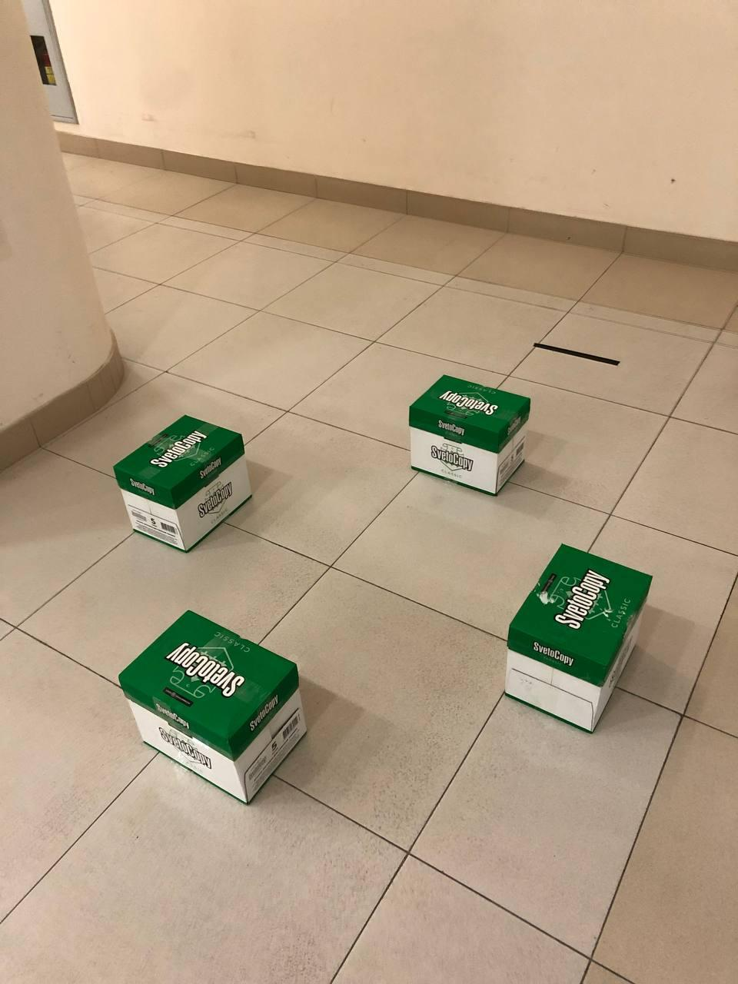

From March 1st we started to work on this assignment. We tried to come up with a solution that fits various environments that is independent of the obstacles and their positions. Every team member came up with an idea. After all the brainstorming and discussion, we decided to use Ultrasonic as an obstacle detector in front of the smart kit. IR sensors are used for avoiding obstacles.

At first, there was no obstacle in front. The kit should go forward until it detects. Once Ultrasonic detects the obstacle 25 cm ahead, turn right until the left IR sensor detects the obstacle. Here, the smart kit ideally would parallel the obstacle. Then continue to go forward until the left IR sensor stops detecting the obstacle. Here is the part of the demo to visualize:



If there is no obstacle in front go forward until it detects one from 25cm:

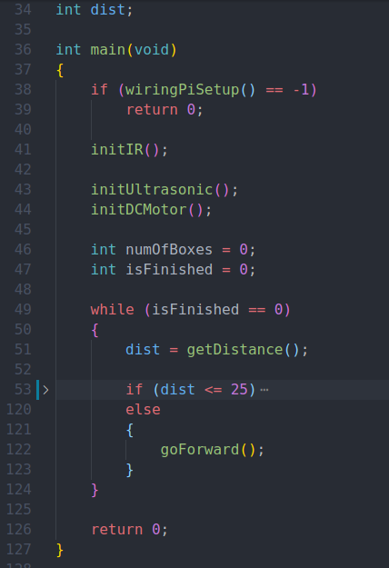

If it detects obstacle from less than 26cm:

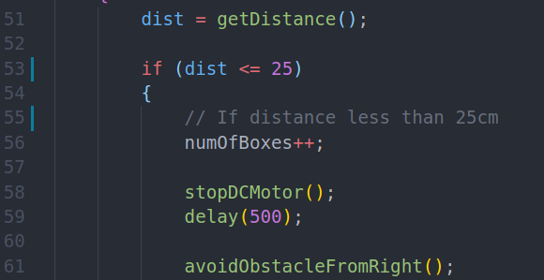

avoidObstacleFromRight function body:

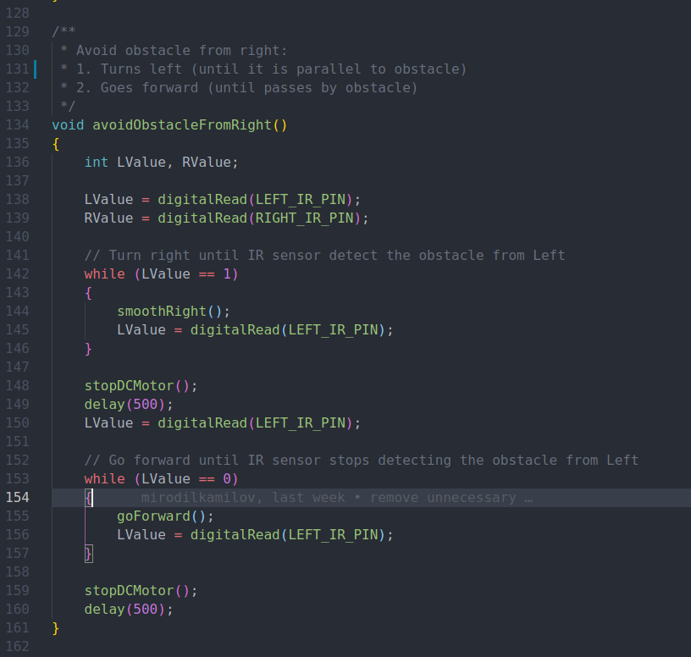

Now, we know how to avoid any obstacle. But we don’t know how to get to the next obstacle. There is a pattern to get to each obstacle. Actually, there is only two variations to get to the next obstacle:

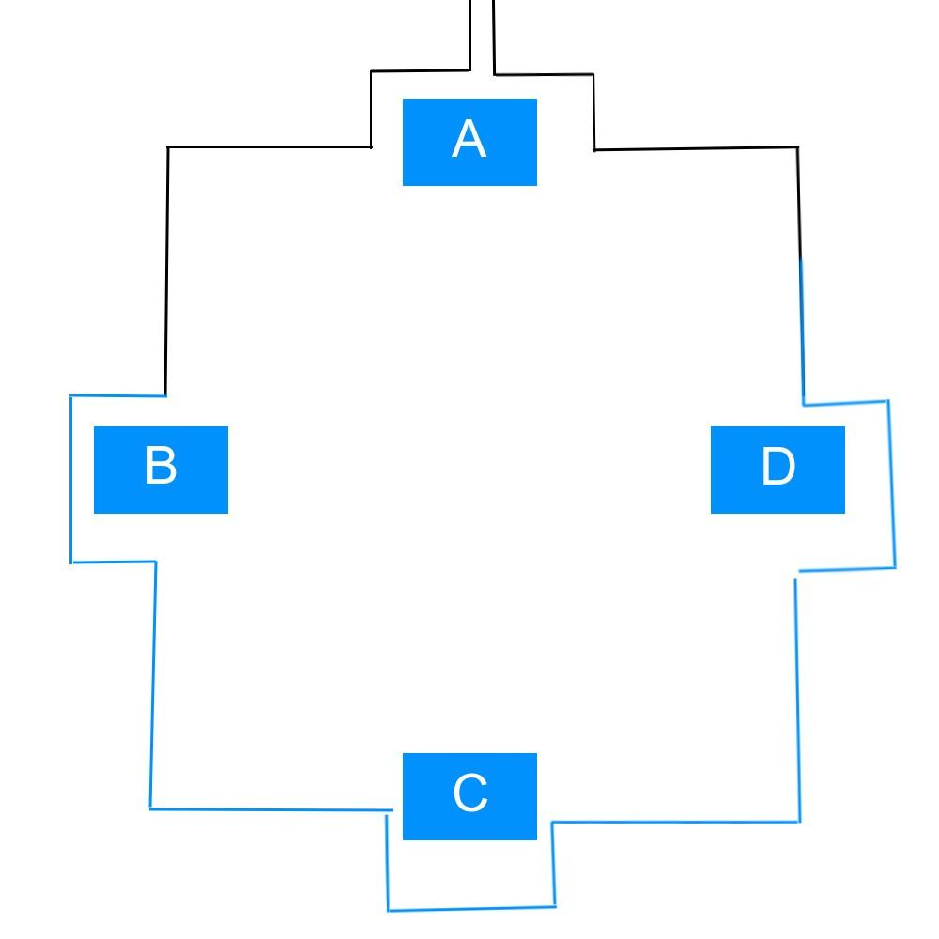

Actions to get A and avoid A (first box) are the same as actions to get A and avoid A (last box). The process of getting to the B, C and D obstacles and avoiding them is also the same. So we counted the number of boxes (as we detect from Ultrasonic) and performed corresponding actions to get and avoid these boxes.

Here is the source code of this part:

It uses some delays to get to the next obstacle depending on the count of the boxes.

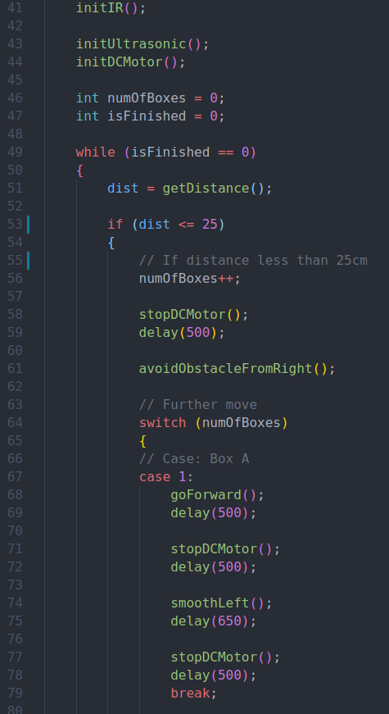

The same code is reused with Boxes B, C, D

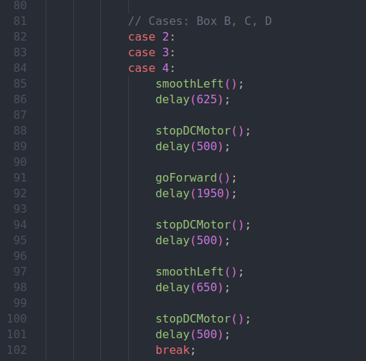

But there was a small modification in the box A (last one). It was meant to cross the finish line:

goForward();

delay(2050);

isFinished = 1; // finish the outer loop to stop the program

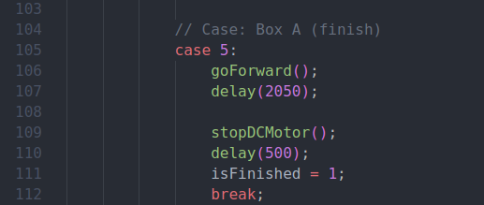

Here is the [demo video](https://www.youtube.com/watch?v=XZjA52h_Uqc) of the first assignment:

[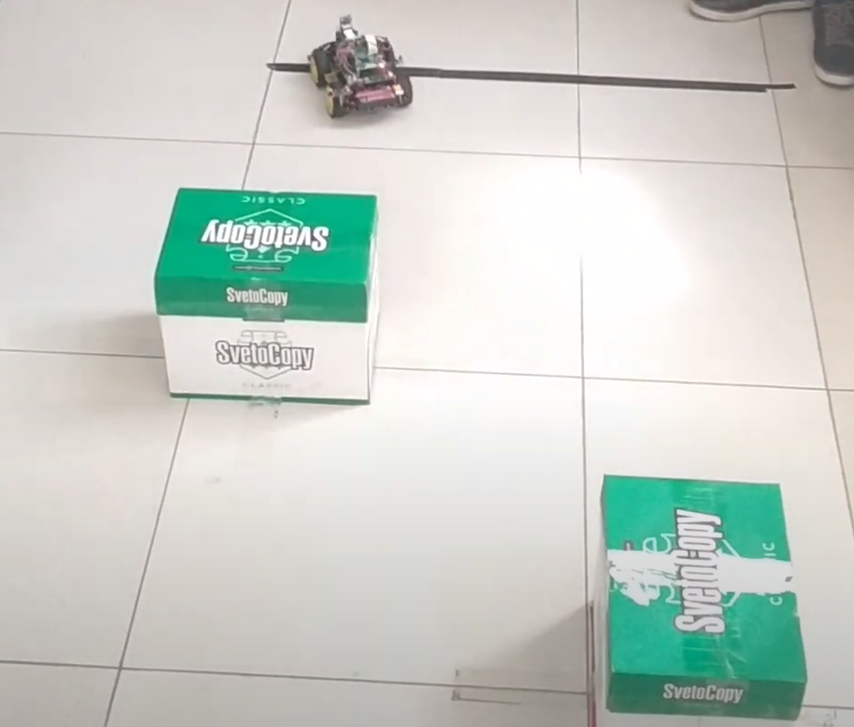](https://www.youtube.com/watch?v=XZjA52h_Uqc)

### 

### Midterm Project

In this midterm project, we were expected to use all sensors (Ultrasonic sensors, IR lane tracers) to complete the project. Here are the requirements of this project:

1. To follow the yellow lines. There are 4 zones to complete the mission.

2. If an obstacle is detected: the first obstacle is 15 cm - just stop and wait until to remove the obstacle, the second obstacle is 15 cm - avoid and continuous movement, the third one in 15 cm - stop the motors.

3. We were given 5 minutes to complete the mission during demo day (multiple trials are possible during this period).

4. We had to use ultrasonic, DC motors, and IR sensors.

Here is the actual map to complete the midterm tasks:

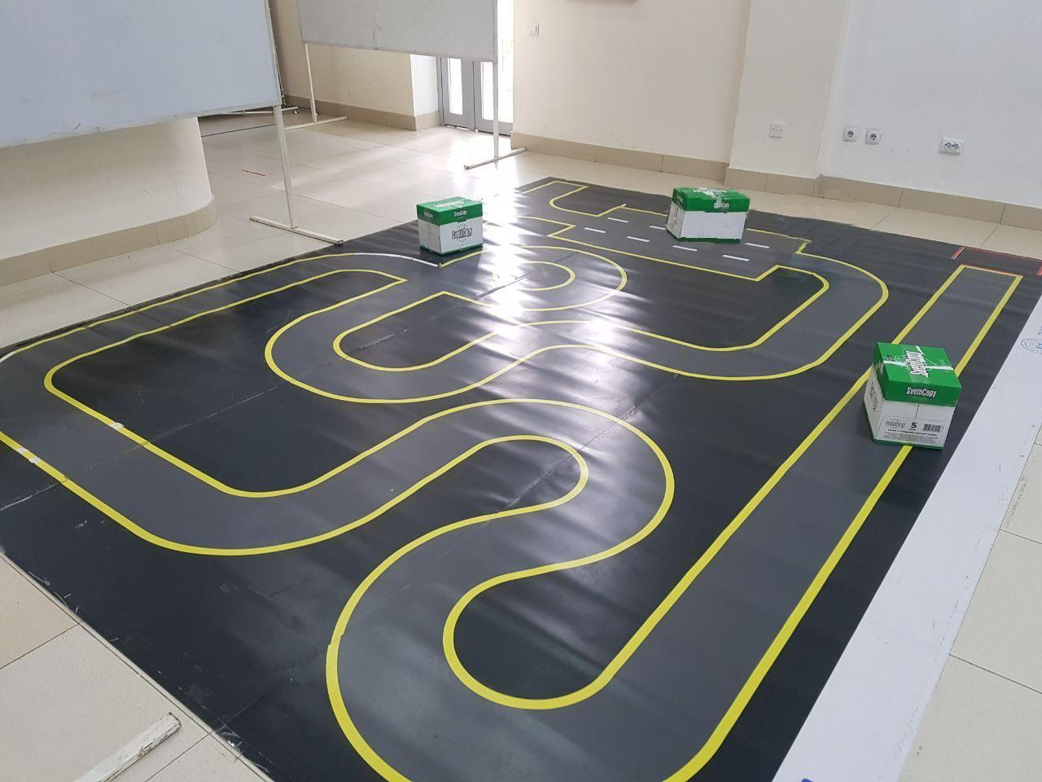

According to our *Team Operations Schedule,* we started to prepare for the midterm project from March 8th. On that day, we tested only IR lane Tracers. The implementation of line tracing that we were given by TA was naive with delays.

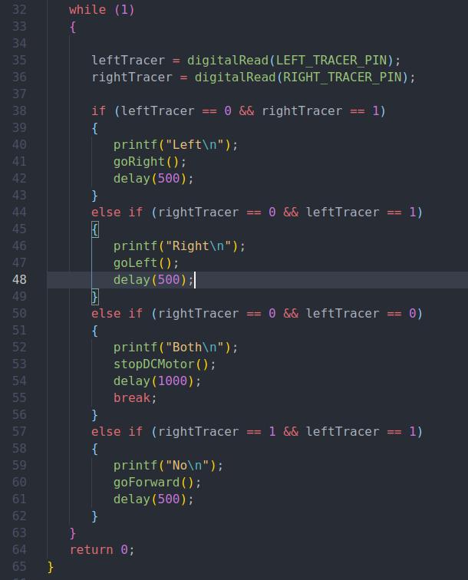

*Default code for IR lane tracing*

It was not an ideal approach to track the lines. Because as voltage of the battery decreases, delay after corresponding action may vary. So, the smart kit may be unable to follow the lines, if the battery power is small. We came up with another solution:

* Line tracers are constantly being checked.
* If a line is detected with one side, the smart kit should turn to the opposite side until the line tracer stops detecting the line.

To better understand our algorithm, we provide the visualization of this approach:



Here is the solution in C programming language:

while (isFinished == 0)

{

...

It continuously checks IR lane tracers. Once all the tasks are completed (all 3 boxes are detected), loop becomes false and the program finishes

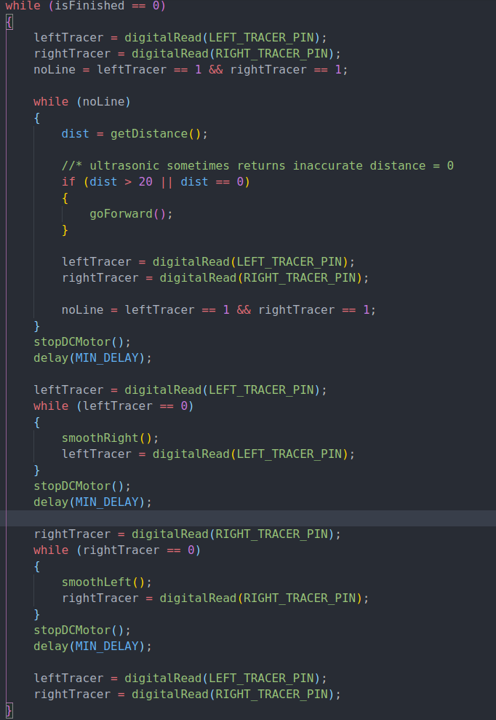

Every time we are inside the while loop we observe the line tracers by calling leftTracer = digitalRead(LEFT_TRACER_PIN); and updating the corresponding IR lane tracer variable.

leftTracer = digitalRead(LEFT_TRACER_PIN);

while (leftTracer == 0)

{

smoothRight();

leftTracer = digitalRead(LEFT_TRACER_PIN);

}

stopDCMotor();

delay(MIN_DELAY);

Once IR lane tracer stops detecting the line we stopDCMotor for minimum delay (100 ms).

This was the outcome of our discussion and brainstorming at the March 8th meeting. At the end of the meeting, we tried to add Ultrasonic code to detect objects. All of a sudden, line tracers reacted slowly to the lines. This problem was assigned to every team member to find a reason and solution by the next meeting (March 11).

At the next meeting (March 11), we discovered that delay in Ultrasonic was slowing our program to follow lines. In fact, the 0.5-second delay was huge for tracing lines. We minimized the delay to the following:

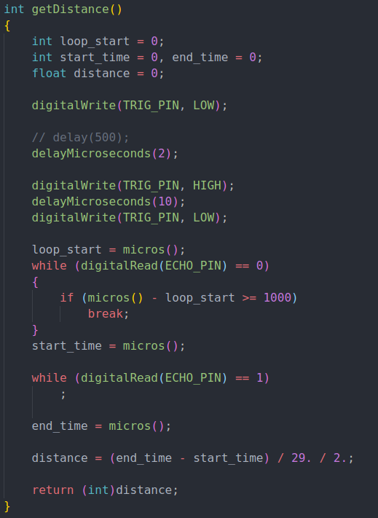

We decreased the 0.5-second delay to a 2-microsecond delay. It broke the measurement of the Ultrasonic. Most of the time execution of the program in the first while loop was infinite. So, we decided to exit that loop if it takes so long.

loop_start = micros();

while (digitalRead(ECHO_PIN) == 0)

{

if (micros() - loop_start >= 1000)

break;

}

Then we mainly focused on designing an algorithm to detect and take corresponding actions depending on the numOfBoxes the car encountered. While there is no line detected, check if there is an obstacle in 20 cm. If there is one, take corresponding action depending on the numOfBoxes counted. Otherwise, keep going forward.

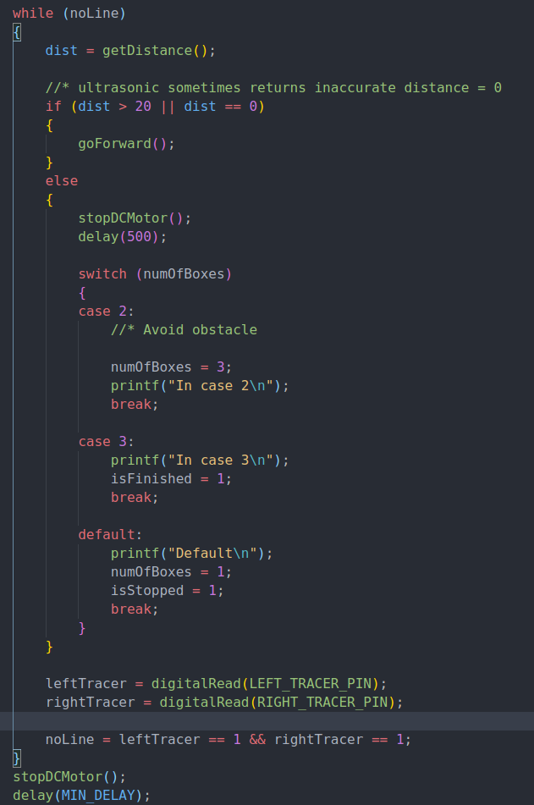

Next problem is to program logic of each corresponding action depending on the numOfBoxes counter.

**First obstacle:** Stop and wait until the obstacle is removed from the way.

By default we set numOfBoxes to 0, we use the variable isStopped to check whether the car has already stopped.

int numOfBoxes = 0;

int isStopped = 0;

First case would be for that default value in default switch case:

Set numOfBoxes and isStopped to 1 in the default switch case. So every iteration of the outer while loop smart kit stops and keeps waiting for the obstacle to be removed. But, where we set numOfBoxes to 2 if the kit successfully goes through the fist box. We set it in the leftTracer detection loop before checking against certain conditions. Because at that time the smart kit would reach to the first right bend of the map.

leftTracer = digitalRead(LEFT_TRACER_PIN);

while (leftTracer == 0)

{

smoothRight();

//* if kit reaches to first right bend update numOfBox

if (isStopped == 1 && numOfBoxes == 1)

{

numOfBoxes = 2;

}

leftTracer = digitalRead(LEFT_TRACER_PIN);

}

stopDCMotor();

delay(MIN_DELAY);

Next problem to solve was writing the logic to avoid the second obstacle. There we used same logic from assignment #1 to turn right after detecting the obstacle. Then we used some actions with delays to ease to get the side of the box:

switch (numOfBoxes)

{

case 2:

//* Avoid obstacle

LValue = digitalRead(LEFT_IR_PIN);

// Turn right until IR sensor detect the obstacle from Left

while (LValue == 1)

{

smoothRight();

LValue = digitalRead(LEFT_IR_PIN);

}

stopDCMotor();

delay(MIN_DELAY);

smoothLeft();

delay(400);

stopDCMotor();

delay(MIN_DELAY);

goBackward();

delay(300);

stopDCMotor();

delay(MIN_DELAY);

Here is that action:



Then we should go forward until the kit detects the line from right. If we detect it, we should make smoothLeft until it stops detecting. Then move forward to pass the box and turn left to the direction the path leads to the third box. Here is implementation:

rightTracer = digitalRead(RIGHT_TRACER_PIN);

while (rightTracer == 1)

{

goForward();

rightTracer = digitalRead(RIGHT_TRACER_PIN);

}

stopDCMotor();

delay(MIN_DELAY);

//* kit is on the side of the obstacle

while (rightTracer == 0)

{

smoothLeft();

rightTracer = digitalRead(RIGHT_TRACER_PIN);

}

stopDCMotor();

delay(MIN_DELAY);

goForward();

delay(300);

smoothLeft();

delay(360);

numOfBoxes = 3;

printf("In case 2\n");

break;

Here is demo of that (in slow motion):



After breaking from this case, the outer loop starts executing again and the car follows the lines (checks if there is a last obstacle) until it finds the last obstacle. So in the last case:

case 3:

printf("In case 3\n");

isFinished = 1;

break;

After stopping the kit, it sets isFinished variable to 1 and later sets left and right tracers to NULL to stop executing the program:

//* At the finish, reset Line Tracers

if (isFinished == 1)

{

leftTracer = NULL;

rightTracer = NULL;

}

That’s it for that day. On the last day before the demo, we tested everything for the last time demonstrated to the TA.

Last but not least, this is how we set up and configured the smart kit:

We put the right IR sensor in front in case the ultrasonic sensor doesn’t work. The Left IR sensor was put at a certain angle in order not to face perpendicular to the line. IR Lane tracers were put as far as from the car to detect the lane as early as possible.

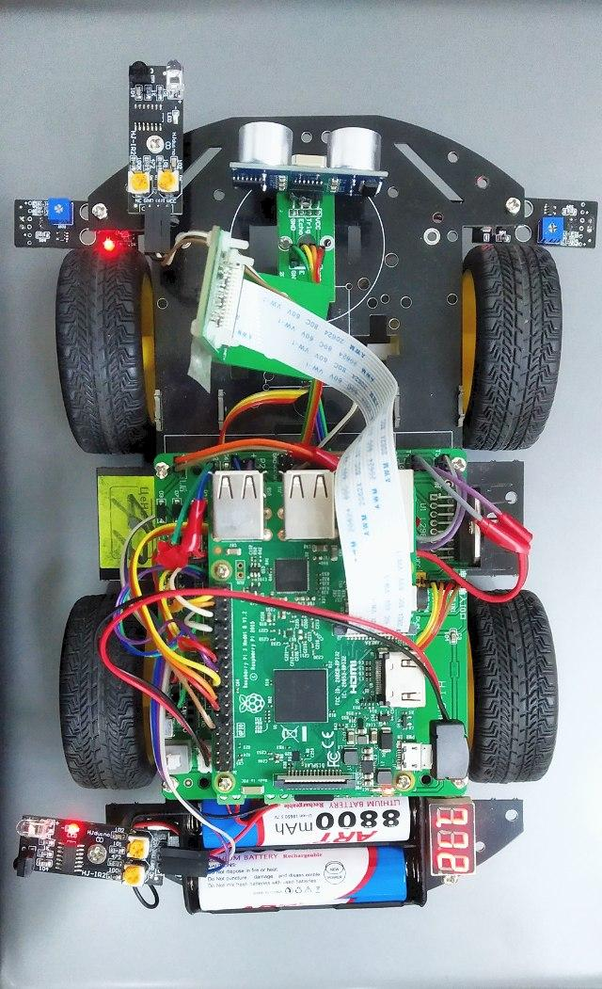

After all, here is the [video of our midterm project demonstration](https://youtu.be/u0C525TeErY):

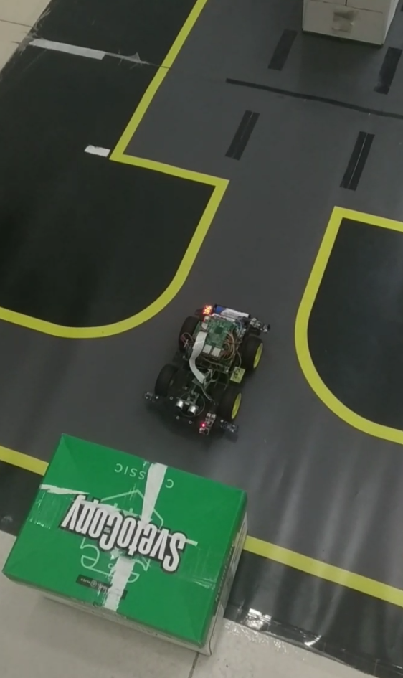

### Summary

Let’s summarize the objective of the project. It includes the following goals:

* Develop an independent project in the given time and limited resources
* Identify a problem, formulate an approach, and handle a considerable technical problem
* Implement a computerized system, consisting of an appropriate mix of software and possibly hardware components, using the techniques, skills, and modern computer system development tools
* Develop effective written and verbal skills to communicate among team members as well as with outsiders in a real-world styled environment.

**Overview**

The Capstone Course is intended to bring together the use of the concepts and skills learned in other courses throughout the whole curriculum. Our project team is responsible for designing, developing, implementing the required system, and demonstrating that it works as required. The primary purpose of the project is to work on an Autonomous vehicle using Raspberry Pi. We will gain profound knowledge through the course and put into practice what we have learned in the class. We will particularly have had deep knowledge in the following topics by the end of the semester

* Programming using basic motor control commands
* Obstacle distance measurement and display
* Motor control program using ultrasonic sensor
* Line tracing and Lane recognition program using image
* Recognition color of traffic signal
* Vehicle control through image recognition

**Further steps**

In the rapidly changing world, the demand for autonomous cars, robots, gadgets, devices is increasing rapidly year by year. They are solving lots of problems in our daily life, saving our time and money, as well as, easing our tasks. After active and successful participation in this course, doing all the required steps in our project, we will learn the basic knowledge about Autonomous Vehicles and open the way towards further studies, research, and career for ourselves in the next steps. Later, we will have a chance of working on real-world projects, i.e. making self-driving cars, buses, delivery services, and so on.